Instructions for accessing your messages via telephone
Formatted: Complex Script Font: 10.5 ptFormatted: Font: 10.5 pt, Complex ScriptFont: 10.5 pt
Deleted: 2
Deleted: Listening to Voicemail Messages
Deleted
To access your messages via telephone
1. Dial the voicemail access feature code (*1 by default). If your telephone forwards to a mailbox you are logged in automatically. If not, you are prompted for a mailbox and password. Alternatively, dial the voicemail login feature code, and you are always asked for a mailbox and password.

2. Follow the prompts to navigate the menus. The following prompts are available at this level:

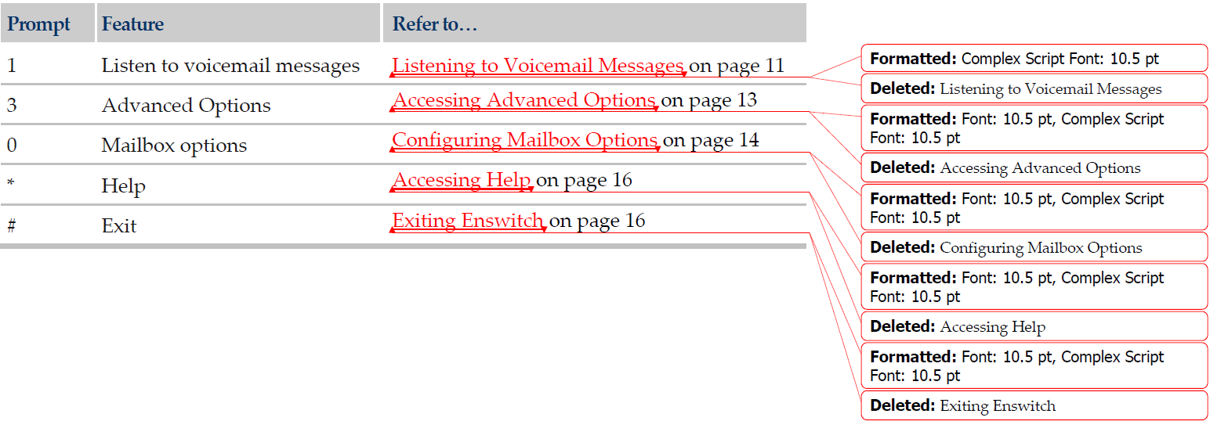
Listeningto Voicemail Messages
You can listen to your voicemail messages.
To listen to your voicemail messages
1. Access your messages via telephone (see Accessing Messages via Telephone).
2. Press 1 to listen to your voicemail messages in your mailbox.
3. Follow the prompts to navigate the menus. The following prompts are available at this level
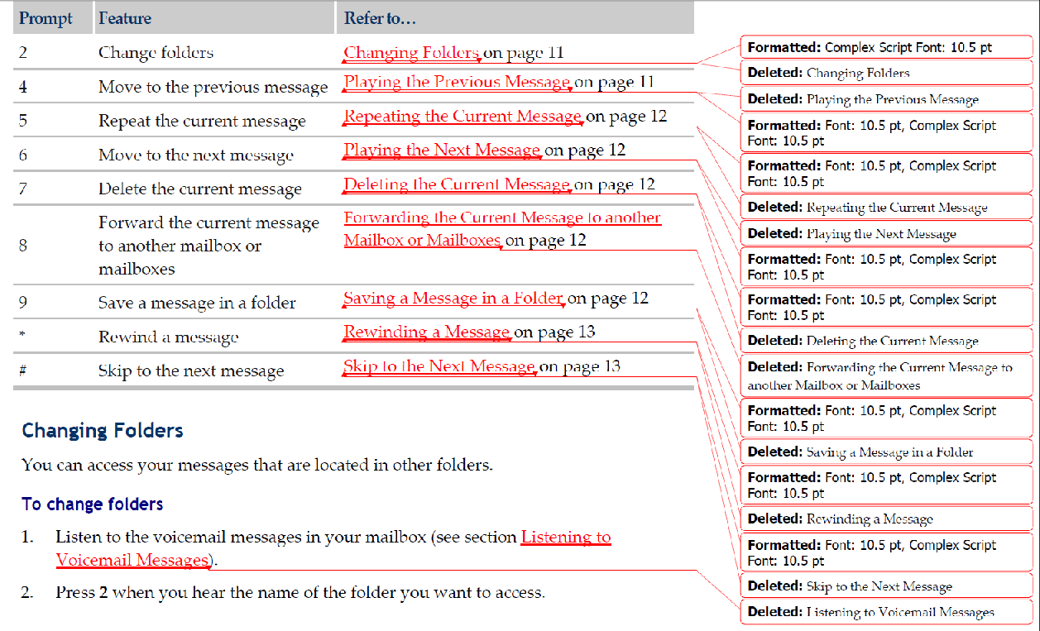

Changing Folders
You can access your messages that are located in other folders.
To change folders
1. Listen to the voicemail messages in your mailbox (see section Listening to Voicemail Messages).
2. Press 2 when you hear the name of the folder you want to access

Playing the Previous Message
You can play the previous message in your mailbox.
To play the previous message
1. Listen to the voicemail messages in your mailbox (see section Listening to Voicemail Messages).
2. Press 4 to play to the previous message.

Repeating the Current Message
You can repeat the current message.
To repeat the current message
1. Listen to the voicemail messages in your mailbox (see section Listening to Voicemail Messages).
2. Press 5 during the message you want to repeat

Playing the Next Message
You can play the next message in your mailbox.
To play the next message
1. Listen to the voicemail messages in your mailbox (see section Listening to Voicemail Messages).
2. Press 6 when you reach the message you want to skip over to move to the next message.

Deleting the Current Message
You can delete the current message.
To delete the current message
1. Listen to the voicemail messages in your mailbox (see section Listening to Voicemail Messages).
2. Press 7 when you reach the message you want to delete.

Forwarding the Current Message to another Mailbox or Mailboxes
You can forward messages to another mailbox or mailboxes.
To forward the current message to another mailbox or mailboxes
1. Listen to the voicemail messages in your mailbox (see section Listening to Voicemail Messages).
2. Press 8 when you reach the message you want to forward.
3. Follow the prompts to select the mailbox or mailboxes to which you want to forward the message.

Saving a Message in a Folder
You can save messages to specific folders.
To save a message
Deleted: Listening to Voicemail Messages

Deleted: Listening to Voicemail Messages

Deleted

1. Listen to the voicemail messages in your mailbox (see section Listening to Voicemail Messages).
2. Press 9 when you reach the message you want to save.
3. Follow the prompts to select the folder to which you want to save the message

Rewinding a Message
You can rewind a message while it is playing.
To rewind a message
1. Listen to the voicemail messages in your mailbox (see section Listening to Voicemail Messages).
2. Press * while the message is playing.

Skip to the Next Message
You can skip the rest of the message you are listening to, and move ahead to the next message.
To skip to the next message
1. Listen to the voicemail messages in your mailbox (see section Listening to Voicemail Messages).
2. Press # while listening to the message you want to skip.

Accessing Advanced Options
The advanced options provide you with the following capabilities:
 Replying to a voicemail
 Playing a message envelope
 Leaving a message
 Returning to the main menu

To access the advanced options
1. Access your messages via telephone (see Accessing Messages via Telephone).
2. Press 3.
3. Follow the prompts to navigate the menus. The following prompts are available at this level.

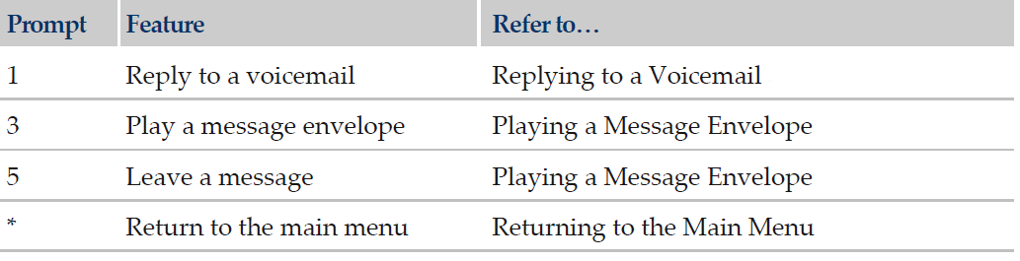
Replying to a Voicemail
You can reply to a voicemail in your mailbox.
To reply to a voicemail
1. Access your mailbox’s advanced options (see Accessing Advanced Options).
2. Press 1 and follow the prompts.
3. Press * to return to the main menu.

Playing a Message Envelope
You can play a message envelope.
To play a message envelope
1. Access your mailbox’s advanced options (see Accessing Advanced Options).
2. Press 3 and follow the prompts.
3. Press * to return to the main menu.

Leaving Messages
To leave a message
1. Access your mailbox’s advanced options (see Accessing Advanced Options).
2. Press 5. And follow the prompts.
3. Press * to return to the main menu.

Returning to the Main Menu
To return to the main menu
Press *.

Configuring Mailbox Options
To configure your mailbox options
1. Access your messages via telephone (see Accessing Messages via Telephone).
2. Press 0.
3. Follow the prompts to navigate the menus. The following prompts are available at this level

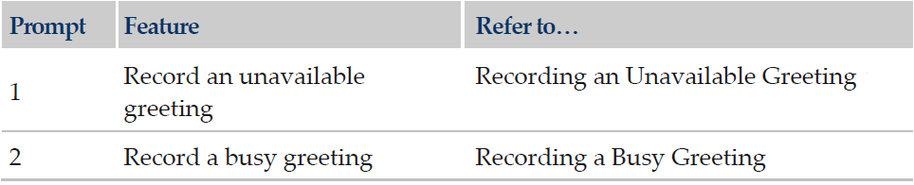

Accessing Messages via Telephone

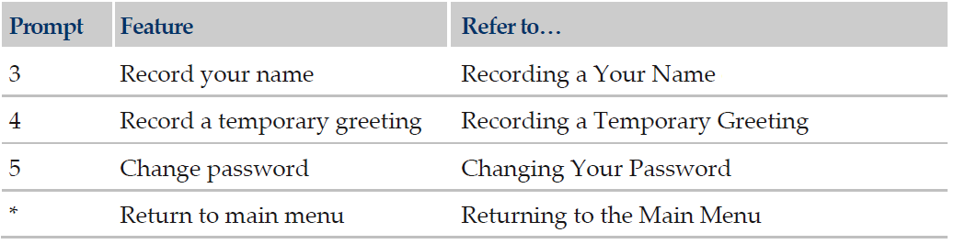
Recording an Unavailable Greeting
You can record a greeting informing callers that you are unavailable.
To record an unavailable greeting
1. Access your mailbox options (see Configuring Mailbox Options).
2. Press 1 and follow the prompts.

Recording a Busy Greeting
You can record a greeting informing callers that the line is busy.
To record a busy greeting
1. Access your mailbox options (see Configuring Mailbox Options).
2. Press 2 and follow the prompts.

Recording a Your Name
You can record your name to inform callers that they have reached your mailbox.
To record your name
- Access your mailbox options (see Configuring Mailbox options)
- Press 3 and follow the prompts

Recording a Temporary Greeting
You can record a temporary greeting that callers will hear when they reach your mailbox during a specified time.
To record a temporary greeting
1. Access your mailbox options (see Configuring Mailbox Options).
2. Press 4 and follow the prompts.

Changing Your Password
You can change the password you use to access your mailbox.
To change your password
1. Access your mailbox options (see Configuring Mailbox Options).
2. Press 5 and follow the prompts.

Accessing Help
To access help
 Press *.

Exiting Enswitch :  Press #.

