**Portal User Guide**

**Portal Release 3.13**

**https://portal.3starsnet.com**

*Contents*

**1 Introduction** 4

**2 Accessing Messages on the Web Interface 4**

2.1 Searching for Messages 4

2.2 Sorting Messages 5

2.3 Downloading Messages 6

2.4 Deleting Messages 6

2.5 Copying or Moving Messages 6

2.6 Accessing Online Help 6

2.7 Logout of Portal 6

**3 Accessing Messages via Telephone 7**

3.1 Listening to Voicemail Messages 8

3.1.1 Changing Folders 8

3.1.2 Playing the Previous Message 8

3.1.3 Repeating the Current Message 8

3.1.4 Playing the Next Message 8

3.1.5 Deleting the Current Message 9

3.1.6 Forwarding the Current Message to another Mailbox

or Mailboxes 9

3.1.7 Saving a Message in a Folder 9

3.1.8 Rewinding a Message 9

3.1.9 Skip to the Next Message 9

3.2 Accessing Advanced Options 9

3.2.1 Replying to a Voicemail 10

3.2.2 Playing a Message Envelope 10

3.2.3 Leaving Messages 10

3.2.4 Returning to the Main Menu 10

3.3 Configuring Mailbox Options 10

3.3.1 Recording an Unavailable Greeting 10

3.3.2 Recording a Busy Greeting 10

3.3.3 Recording a Your Name 11

3.3.4 Recording a Temporary Greeting 11

3.3.5 Changing Your Password 11

3.4 Accessing Help 11

3.5 Exiting Portal 11

**4** **Accessing Messages via Telephone (Experimental Menus)** 11

4.1 Moving to the First Message in the Current Folder 12

4.2 Changing Folders 12

4.3 Playing a Message Envelope 12

4.4 Replaying the Previous Message 12

4.5 Repeating the Current Message 12

4.6 Moving to the Next Message 12

4.7 Deleting the Current Message 13

4.8 Moving or Copying the Current Message to a Different Folder 13

4.9 Forwarding the Current Message to another Mailbox 13

4.10 Configuring Mailbox Options 13

4.10.1 Recording an Unavailable Greeting 13

4.10.2 Recording a Busy Greeting 13

4.10.3 Recording a Your Name 14

4.10.4 Recording a Temporary Greeting 14

4.10.5 Changing Your Password 14

**5** **Call Park** 14

**6** **Click to Call** 15

**7 Forwarding to an External Extension** 16

**1 Introduction**

Portal enables users to access and navigate their messages and mailbox options via the web interface or via telephone. Portal features provide users with the flexibility to pause an incoming call and continue from another phone, or to make a call via the web interface. The following sections describe how to access the various Portal features, and provided suggested scenarios applicable to some of these features.

**2 Accessing Messages on the Web Interface**

This chapter provides instructions for accessing your messages via the web interface. Chapter ‎3 Accessing Messages via Telephone provides instructions for accessing your messages via telephone.

**To access your messages from the web interface**

1. Log in to the Portal web interface.

2. Select the **Messages** menu.

3. By default, all messages are shown. If you want to see a specific message type, select one of the following options:

All mailboxes

Faxes

Voicemails

Text messages

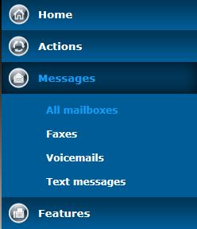

4. If you have access to more than one mailbox, select the mailbox you want to view. The messages in the selected mailbox appear.

**2.1 Searching for Messages**

You can search for a specific message or group of messages to display. Your search can be based on a variety of search parameters, including a message’s folder location, start and end date, duration, and/or the calling number or name.

**To search for a message**

1. Log in to the Portal web interface.

2. Access the type of messages you want to search for (see Accessing Messages on the Web Interface).



3. Enter the following search parameters:

**Folder:**Select the folder in which the messages are located.

**Start date:** From the drop-down lists select the start date of the messages you want to locate or click the Calendar icon and select the start date.

**End date:** From the drop-down lists select the end date of the messages you want to locate or click the Calendar icon to select the end date.

**Minimum duration (seconds**): The minimum duration, in seconds, of messages for which you want to search.

**Maximum duration (second):** The maximum duration, in seconds, of messages for which you want to search.

**Calling number or name contains:** Enter all or part of the calling number or name associated with the messages you want to locate.

4. Click **Update**.

**2.2 Sorting Messages**

You can sort the displayed messages based on the messages dates and times, durations, and caller names.

**To sort messages**

1. Log in to the Portal web interface.

2. Access the type of messages you want to display (see Accessing Messages on the Web Interface).

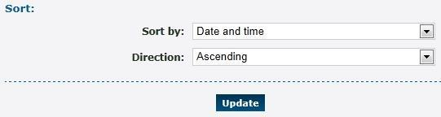

3. From the **Sort by** drop-down list, select how to sort your messages. Options are:

Date and time

Duration

Caller

4. From the **Direction** drop-down list, select to sort your messages in **Ascending** or **Descending** order.

5. Click **Update**.

**2.3 Downloading Messages**

You can download a message from the web interface onto your computer. This enables you to access the message even when you are not connected to the internet or logged in to the Portal web interface.

**To download a message:**

1. Log in to the Portal web interface.

2. Access the type of messages you want to download (see Accessing Messages on the Web Interface).

3. Click the message you want to download.

4. Select a location in which to save the message.

**2.4 Deleting Messages**

**To delete a messages**

1. Log in to the Portal web interface.

2. Access the type of messages you want to delete (see Accessing Messages on the Web Interface).

3. Select the checkboxes corresponding to the messages you want to delete.

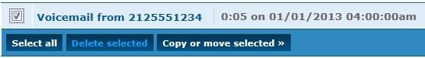

**Note:** Click **Select all** to select all message to delete.

4. Click **Delete selected**. A message appears asking you to confirm that you want to delete the selected message.

5. Click **OK**.

**2.5 Copying or Moving Messages**

**To copy or move a messages**

1. Log in to the Portal web interface.

2. Access the type of messages you want to copy or move (see Accessing Messages on the Web Interface).

3. Select the checkboxes corresponding to the messages you want to copy or move.

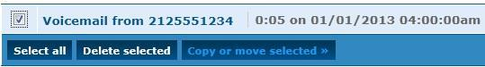

4. Click **Copy or move selected**.

5. From the drop-down list, select to **Copy** or **Move** the message.

6. To copy or move the message to a specific folder, select the folder from the **To** **Folder** drop-down list.

7. To copy or move the message to a mailbox or a group of mailboxes, in the **or to** **mailboxes** section, select the mailboxes from the right column and click **Add** **Selected**.

Note: To remove a mailbox or a group of mailboxes from this option, select the mailboxes in the left column and click **Remove Selected**.

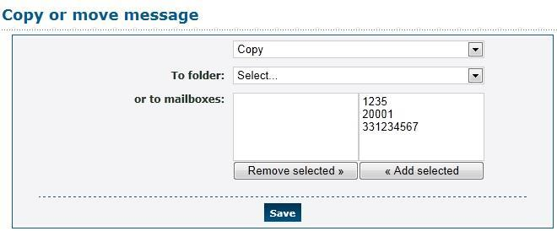

8. Click **Save**.

**2.6 Accessing Online Help**

**To access online help**

1. Log in to the Portal web interface.

2. Select **Actions » More Information**. A Portal page with links to various Portal guides appears.

3. Select **User**. The user online help appears.

**2.7 Logout of Portal**

**To exit Portal from the web interface**

1. Click the down arrow at the top right of the page.

2. Select **Log out**.

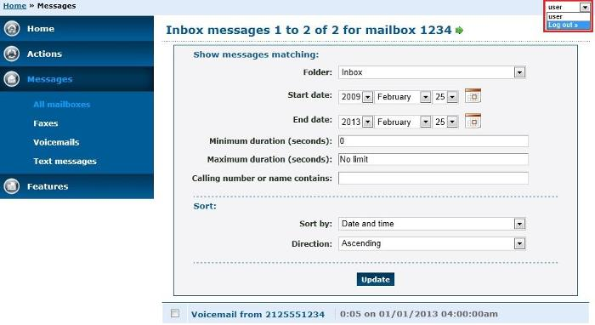

**3 Accessing Messages via Telephone**

This chapter provides instructions for accessing your messages via telephone. Chapter ‎2 Accessing Messages on the Web Interface provides instructions for accessing your messages via the web interface.

**To access your messages via telephone**

1. Dial the voicemail access feature code (**\*1** by default). If your telephone forwards to a mailbox you are logged in automatically. If not, you are prompted for a mailbox and password. Alternatively, dial the voicemail login feature code, and you are always asked for a mailbox and password.

2. Follow the prompts to navigate the menus. The following prompts are available at this level:

**Prompt Feature Refer to…**

1 Listen to voicemail messages Listening to Voicemail Messages on page 11

3 Advanced Options Accessing Advanced Options on page 13

0 Mailbox options Configuring Mailbox Options on page 14

* Help Accessing Help on page 16

**3.1 Listening to Voicemail Messages**

You can listen to your voicemail messages.

**To listen to your voicemail messages**

1. Access your messages via telephone (see Accessing Messages via Telephone).

2. Press **1** to listen to your voicemail messages in your mailbox.

3. Follow the prompts to navigate the menus. The following prompts are available at this level:

**Prompt Feature Refer to…**

2 Change folders Changing Folders on page 11

4 Move to the previous message Playing the Previous Message on page 11

5 Repeat the current message Repeating the Current Message on page 12

6 Move to the next message Playing the Next Message on page 12

7 Delete the current message Deleting the Current Message on page 12

8 Forward the current message to Forwarding the Current Message to another Mailbox another mailbox or mailboxes or Mailboxes on page 12

9 Save a message in a folder Saving a Message in a Folder on page 12

* Rewind a message Rewinding a Message on page 13

# Skip to the next message Skip to the Next Message on page 13

***3.1.1 Changing Folders***

You can access your messages that are located in other folders.

**To change folders**

1. Listen to the voicemail messages in your mailbox (see section Listening to Voicemail Messages).

2. Press **2** when you hear the name of the folder you want to access.

***3.1.2 Playing the Previous Message***

You can play the previous message in your mailbox.

**To play the previous message**

1. Listen to the voicemail messages in your mailbox (see section Listening to Voicemail Messages).

2. Press **4** to play to the previous message.

***3.1.3 Repeating the Current Message***

You can repeat the current message.

**To repeat the current message**

1. Listen to the voicemail messages in your mailbox (see section Listening to Voicemail Messages).

2. Press **5** during the message you want to repeat.

***3.1.4 Playing the Next Message***

You can play the next message in your mailbox.

**To play the next message**

1. Listen to the voicemail messages in your mailbox (see section Listening to Voicemail Messages).

2. Press **6** when you reach the message you want to skip over to move to the next message.

***3.1.5 Deleting the Current Message***

You can delete the current message.

**To delete the current message**

1. Listen to the voicemail messages in your mailbox (see section Listening to Voicemail Messages).

2. Press **7** when you reach the message you want to delete.

***3.1.6 Forwarding the Current Message to another Mailbox or Mailboxes***

You can forward messages to another mailbox or mailboxes.

**To forward the current message to another mailbox or mailboxes**

1. Listen to the voicemail messages in your mailbox (see section Listening to Voicemail Messages).

2. Press **8** when you reach the message you want to forward.

3. Follow the prompts to select the mailbox or mailboxes to which you want to forward the message.

***3.1.7 Saving a Message in a Folder***

You can save messages to specific folders.

**To save a message**

1. Listen to the voicemail messages in your mailbox (see section Listening to Voicemail Messages).

2. Press **9** when you reach the message you want to save.

3. Follow the prompts to select the folder to which you want to save the message.

***3.1.8 Rewinding a Message***

You can rewind a message while it is playing.

**To rewind a message**

1. Listen to the voicemail messages in your mailbox (see section Listening to Voicemail Messages).

2. Press **\*** while the message is playing.

***3.1.9 Skip to the Next Message***

You can skip the rest of the message you are listening to, and move ahead to the next message.

**To skip to the next message**

1. Listen to the voicemail messages in your mailbox (see section Listening to Voicemail Messages).

2. Press **#** while listening to the message you want to skip.

**3.2 Accessing Advanced Options**

The advanced options provide you with the following capabilities:

Replying to a voicemail

Playing a message envelope

Leaving a message

Returning to the main menu

**To access the advanced options**

1. Access your messages via telephone (see Accessing Messages via Telephone).

2. Press **3**.

3. Follow the prompts to navigate the menus. The following prompts are available at this level:

**Prompt Feature Refer to…**

1 Reply to a voicemail Replying to a Voicemail on page 14

3 Play a message envelope Playing a Message Envelope on page 14

5 Leave a message Playing a Message Envelope on page 14

* Return to the main menu Returning to the Main Menu on page 14

***3.2.1 Replying to a Voicemail***

You can reply to a voicemail in your mailbox.

**To reply to a voicemail**

1. Access your mailbox’s advanced options (see Accessing Advanced Options).

2. Press **1** and follow the prompts.

3. Press **\*** to return to the main menu.

***3.2.2 Playing a Message Envelope***

You can play a message envelope.

**To play a message envelope**

1. Access your mailbox’s advanced options (see Accessing Advanced Options).

2. Press **3** and follow the prompts.

3. Press **\*** to return to the main menu.

***3.2.3 Leaving Messages***

**To leave a message**

1. Access your mailbox’s advanced options (see Accessing Advanced Options).

2. Press **5**. And follow the prompts.

3. Press **\*** to return to the main menu.

***3.2.4 Returning to the Main Menu***

**To return to the main menu**

Press *.

**3.3 Configuring Mailbox Options**

**To configure your mailbox options**

1. Access your messages via telephone (see Accessing Messages via Telephone).

2. Press **0**.

3. Follow the prompts to navigate the menus. The following prompts are available at this level:

**Prompt Feature Refer to…**

1 Record an unavailable greeting Recording an Unavailable Greeting on page 15

2 Record a busy greeting Recording a Busy Greeting on page 15

3 Record your name Recording a Your Name on page 15

4 Record a temporary greeting Recording a Temporary Greeting on page 15

5 Change password Changing Your Password on page 16

* Return to main menu Returning to the Main Menu on page 14

***3.3.1 Recording an Unavailable Greeting***

You can record a greeting informing callers that you are unavailable.

**To record an unavailable greeting**

1. Access your mailbox options (see Configuring Mailbox Options).

2. Press **1** and follow the prompts.

***3.3.2 Recording a Busy Greeting***

You can record a greeting informing callers that the line is busy.

**To record a busy greeting**

1. Access your mailbox options (see Configuring Mailbox Options).

2. Press **2** and follow the prompts.

***3.3.3 Recording a Your Name***

You can record your name to inform callers that they have reached your mailbox.

**To record your name**

1. Access your mailbox options (see Configuring Mailbox Options).

2. Press **3** and follow the prompts.

***3.3.4 Recording a Temporary Greeting***

You can record a temporary greeting that callers will hear when they reach your mailbox during a specified time.

**To record a temporary greeting**

1. Access your mailbox options (see Configuring Mailbox Options).

2. Press **4** and follow the prompts.

***3.3.5 Changing Your Password***

You can change the password you use to access your mailbox.

**To change your password**

1. Access your mailbox options (see Configuring Mailbox Options).

2. Press **5** and follow the prompts.

**3.4 Accessing Help**

**To access help**

Press **\***.

**3.5 Exiting Portal**

**To exit Portal**

Press **#**.

**4 Accessing Messages via Telephone** **(Experimental Menus)**

This chapter describes the new experimental voicemail menus which can be accessed via the telephone. This is only applicable if this option has been enabled on your system. If not, refer to Chapter ‎3 Telephone for the traditional voicemail menus.

**To access your messages via the telephone experimental menus**

1. Dial the voicemail access feature code (*1 by default). If your telephone forwards calls to a mailbox, you are logged in automatically. If not, you are asked for a mailbox and password. Alternatively, dial the voicemail login feature code, and you are always asked for a mailbox and password.

If you have any urgent messages, the urgent folder opens first. If not, the inbox folder opens.

2. Follow the prompts to navigate the menus. The following prompts are available at this level:

**Prompt Feature Refer to…**

1 Move to the first message in this folder Moving to the First Message in the Current Folder on page 18

2 Change folders Changing Folders on page 18

3 Play message envelope Playing a Message Envelope on page 18

4 Move to the previous message Replaying the Previous Message on page 18

5 Repeat the current message Repeating the Current Message on page 19

6 Move to the next message Moving to the Next Message on page 19

7 Delete the current message Deleting the Current Message on page 19

8 Move or copy the current message Moving or Copying the Current Message to to a different folder a Different Folder on page 19

9 Forward the current Forwarding the Current Message to another message to another mailbox Mailbox on page 20

0 Mailbox options Configuring Mailbox Options on page 20

* Help Accessing Help on page 16

# Exit Exiting Portal on page 16

**4.1 Moving to the First Message in the Current Folder**

You can access the first message in the current folder.

**To move to the first message in the current folder**

1. Access your messages via telephone (see Accessing Messages via Telephone (Experimental Menus)).

2. Press **1**.

**4.2 Changing Folders**

You can access your messages in other folders.

**To change folders**

1. Access your messages via telephone (see Accessing Messages via Telephone (Experimental Menus)).

2. Press **1** to listen to your voicemail messages in your mailbox. A menu of the existing folders is played.

3. Press **2** when you hear the name of the folder you want to access.

**4.3 Playing a Message Envelope**

You can play a message envelope.

**To play a message envelope**

1. Access your messages via telephone (see Accessing Messages via Telephone (Experimental Menus)).

2. Press **3**.

**4.4 Replaying the Previous Message**

You can replay the previous message

.

**To replay the previous message**

1. Access your messages via telephone (see Accessing Messages via Telephone (Experimental Menus)).

2. Press **4** to return to the previous message.

**4.5 Repeating the Current Message**

You can go back to the beginning of a message to hear it again.

**To repeat the current message**

1. Access your messages via telephone (see Accessing Messages via Telephone (Experimental Menus)).

2. Press **5** during the message you want to repeat.

**4.6 Moving to the Next Message**

You can skip the rest of the message you are listening to, and move ahead to the next message.

**To move to the next message**

1. Access your messages via telephone (see Accessing Messages via Telephone (Experimental Menus)).

2. Press **6** to access the next message.

**4.7 Deleting the Current Message**

You can delete the current message.

**To delete the current message**

1. Access your messages via telephone (see Accessing Messages via Telephone (Experimental Menus)).

2. Press **7** when you reach the message you want to delete.

**4.8 Moving or Copying the Current Message to a Different**

**Folder**

You can move or copy the current message to another folder.

**To move or copy the current message to a different folder**

1. Access your messages via telephone (see Accessing Messages via Telephone (Experimental Menus)).

2. Press **8** when you reach the message you want to move or copy, and follow the prompts.

**4.9 Forwarding the Current Message to another Mailbox**

You can forward messages to another mailbox

**To forward the current message to another mailbox**

1. Access your messages via telephone (see Accessing Messages via Telephone (Experimental Menus)).

2. Press **9** when you reach the message you want to forward, and follow the prompts.

**4.10 Configuring Mailbox Options**

**To configure mailbox options**

1. Access your messages via telephone (see Accessing Messages via Telephone (Experimental Menus)).

2. Press **0** to configure the options in your mailbox.

3. Follow the prompts to navigate the menus. The following prompts are available at this level:

**Prompt Feature Refer to…**

1 Record an unavailable greeting Recording an Unavailable Greeting on page 20

2 Record a busy greeting Recording a Busy Greeting on page 21

3 Record your name Recording a Your Name on page 21

4 Record a temporary greeting Recording a Temporary Greeting on page 21

5 Change password Changing Your Password on page 21

* Return to main menu Returning to the Main Menu on page 14

**4.10.1 Recording an Unavailable Greeting**

You can record a greeting informing callers that you are unavailable.

**To record an unavailable greeting**

1. Access your mailbox options (see Configuring Mailbox Options).

2. Press **1** and follow the prompts.

To record or re-record the greeting, press **1** and follow the prompts.

To listen to the existing greeting, press **2**.

To delete the existing greeting, press

**4.10.2 Recording a Busy Greeting**

You can record a greeting informing callers that the line is busy.

**To record a busy greeting**

1. Access your mailbox options (see Configuring Mailbox Options).

2. Press **2** and follow the prompts.

◻ To record or re-record the greeting, press **1** and follow the prompts.

◻ To listen to the existing greeting, press **2**.

◻ To delete the existing greeting, press **3**.

**4.10.3 Recording a Your Name**

You can record your name to inform callers that they have reached your mailbox.

**To record your name**

1. Access your mailbox options (see Configuring Mailbox Options).

2. Press **3** and follow the prompts.

To record or re-record the name, press **1** and follow the prompts.

To listen to the existing name, press **2**.

To delete the existing name, press **3**.

**4.10.4 Recording a Temporary Greeting**

You can record a temporary greeting that callers will hear when they reach your mailbox during a specified time.

**To record a temporary greeting**

1. Access your mailbox options (see Configuring Mailbox Options).

2. Press **4** and follow the prompts.

To record or re-record the greeting, press **1** and follow the prompts.

To listen to the existing greeting, press **2**.

To delete the existing greeting, press **3**.

To activate or deactivate the greeting, press **4**.

*Note: Activating or deactivating the greeting applies only to the temporary greeting.*

**4.10.5 Changing Your Password**

You can change the password you use to access your mailbox.

**To change your password**

1. Access your mailbox options (see Configuring Mailbox Options).

2. Press **5** and follow the prompts.

**5 Call Park**

Call Park enables you to put a call on hold on one telephone set and continue the conversation from another telephone set.

**To park and pick up a call**

1. Answer an inbound call.

2. After talking to the caller, press **#**. You hear "Transfer".

3. Press the park code. By default, the park code is **\*7**.

4. Wait two seconds. You hear a park number, such as 701.

5. Hang up.

6. Call the park number from another telephone.

**Note**: Only inbound calls can be parked. Outbound calls cannot be parked to allow the # button to work with external IVRs.

**6 Click to Call**

Click to Call allows you to make a call via the web interface or JSON API.

The following are possible scenarios:

Speed dials from your web browser's bookmarks.

Integration with desktop applications such as email clients. To do this, invoke the following URL: http://Portal.example.com/actions/call/save/?_username=<Portal username>&_password=<Portal password>&stype=phone&phone=<telephone line to call from>&cnumber=<number to call>

"Click here to call us" buttons on your website.

To do this, configure a CGI script on your web server to invoke the following URL: http://Portal.example.com/actions/call/save/?_username=<Portal username>&_password=<Portal password>&snumber=<customer number to call first>&cnumber=<feature code pointing to queue or hunt group>

**Note:** It is important to use a script rather than a link to avoid revealing your username and password.

**To call via the web interface**

1. Log in to the Portal web interface.

2. Select **Actions » Make a call** to display the Make a call form.

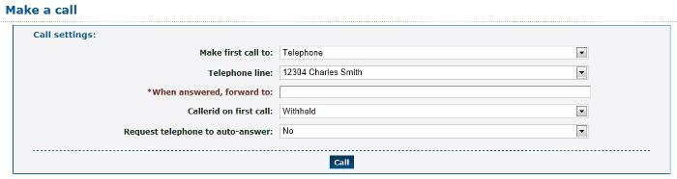

3. Enter the following: (fields marked with are required):

**Make first call to:** Choose the first destination to call. This can be a telephone line or an arbitrary number. If a number, it is routed as though you had dialed it from a telephone.

**Telephone line:** If you select Telephone, select the telephone line.

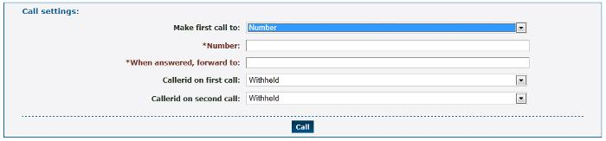

* **Number:** If you select Number, enter the phone number.
* **When answered, forward to:** Choose a number to transfer to once the first destination has answered. This can be an arbitrary number, such as an external number, number, feature code, or telephone line.
* **Callerid on first call:** Choose the callerid number to display on the first call. Choose **Withheld** if you do not want the number displayed.
* **Callerid** on second call: Choose the callerid number to display on the second call. Choose **Withheld** if you do not want the number displayed.

4. Click **Call**. The first destination should ring within a few seconds.

5. You can bookmark the next page to make the same call in future

**7 Forwarding to an External Extension**

Many features allow you to forward a call to an external number using the "External number" entry box on the destination selector. You can play DTMF to the destination if this is required to specify a particular extension. For example, to dial "2125551234" and play DTMF "123" when answered, enter "2125551234x123" in the external number entry box. Anything after the "x" is taken to be DTMF to play.

You may need to delay the DTMF depending on the menu the far end plays. You can do this by adding a "w" to the string specified. Each "w" creates a delay of 0.5 seconds. You may specify as many of these as you wish. For example, "2125551234xwwww1w123" will dial 2125551234, then, when answered, waits two seconds, plays a 1, waits another 0.5 seconds, plays 123, then connects the caller. Some experimentation may be required to find the correct combination of DTMF and waiting.